**Hands-On: Stage 3 - C# Additional Topics Other Application Types- Windows Forms, Windows Service - Day 4 – Handson**

**Windows forms application 1**

**Form1.cs**

using System;

using System.Text.RegularExpressions;

using System.Windows.Forms;

namespace WindowsFormsApplication1

{

    public partial class Form1 : Form

    {

        public Form1()

        {

            InitializeComponent();

        }

        private void Form1_Load(object sender, EventArgs e)

        {

        }

        private void button1_Click(object sender, EventArgs e)

        {

            string input1 = textBox1.Text;

            string input2 = textBox2.Text;

            if (!Regex.IsMatch(input1, @"\d+$") || !Regex.IsMatch(input2, @"\d+$"))

{

                MessageBox.Show(" Please enter valid input for the operands") ;

            }

            if (radioButton1.Checked)

            {

                MessageBox.Show((int.Parse(input1) + int.Parse(input2)).ToString());

            }

            else if (radioButton2.Checked)

            {

                MessageBox.Show((int.Parse(input1) - int.Parse(input2)).ToString());

            }

            else if (radioButton3.Checked)

            {

                MessageBox.Show((int.Parse(input1) * int.Parse(input2)).ToString());

            }

            else if (radioButton4.Checked)

            {

                MessageBox.Show((int.Parse(input1) / int.Parse(input2)).ToString());

            }

            else

            {

                MessageBox.Show("Please Select a valid Option");

            }

        }

    }

}

**Form1.Designer.cs**

namespace WindowsFormsApplication1

{

    partial class Form1

    {

        /// <summary>

        ///  Required designer variable.

        /// </summary>

        private System.ComponentModel.IContainer components = null;

        /// <summary>

        ///  Clean up any resources being used.

        /// </summary>

        /// <param name="disposing">true if managed resources should be disposed; otherwise, false.</param>

        protected override void Dispose(bool disposing)

        {

            if (disposing && (components != null))

            {

                components.Dispose();

            }

            base.Dispose(disposing);

        }

        #region Windows Form Designer generated code

        /// <summary>

        ///  Required method for Designer support - do not modify

        ///  the contents of this method with the code editor.

        /// </summary>

        private void InitializeComponent()

        {

            this.textBox1 = new System.Windows.Forms.TextBox();

            this.textBox2 = new System.Windows.Forms.TextBox();

            this.button1 = new System.Windows.Forms.Button();

            this.radioButton1 = new System.Windows.Forms.RadioButton();

            this.radioButton2 = new System.Windows.Forms.RadioButton();

            this.radioButton3 = new System.Windows.Forms.RadioButton();

            this.radioButton4 = new System.Windows.Forms.RadioButton();

            this.SuspendLayout();

            //

            // textBox1

            //

            this.textBox1.Location = new System.Drawing.Point(146, 62);

            this.textBox1.Name = "textBox1";

            this.textBox1.Size = new System.Drawing.Size(125, 27);

            this.textBox1.TabIndex = 0;

            //

            // textBox2

            //

            this.textBox2.Location = new System.Drawing.Point(367, 62);

            this.textBox2.Name = "textBox2";

            this.textBox2.Size = new System.Drawing.Size(125, 27);

            this.textBox2.TabIndex = 1;

            //

            // button1

            //

            this.button1.Location = new System.Drawing.Point(270, 206);

            this.button1.Name = "button1";

            this.button1.Size = new System.Drawing.Size(94, 29);

            this.button1.TabIndex = 6;

            this.button1.Text = "Calculate";

            this.button1.UseVisualStyleBackColor = true;

            this.button1.Click += new System.EventHandler(this.button1_Click);

            //

            // radioButton1

            //

            this.radioButton1.AutoSize = true;

            this.radioButton1.Location = new System.Drawing.Point(72, 133);

            this.radioButton1.Name = "Addition";

            this.radioButton1.Size = new System.Drawing.Size(117, 24);

            this.radioButton1.TabIndex = 7;

            this.radioButton1.TabStop = true;

            this.radioButton1.Text = "Addition";

            this.radioButton1.UseVisualStyleBackColor = true;

            //

            // radioButton2

            //

            this.radioButton2.AutoSize = true;

            this.radioButton2.Location = new System.Drawing.Point(238, 133);

            this.radioButton2.Name = "Subtraction";

            this.radioButton2.Size = new System.Drawing.Size(117, 24);

            this.radioButton2.TabIndex = 8;

            this.radioButton2.TabStop = true;

            this.radioButton2.Text = "Subtraction";

            this.radioButton2.UseVisualStyleBackColor = true;

            //

            // radioButton3

            //

            this.radioButton3.AutoSize = true;

            this.radioButton3.Location = new System.Drawing.Point(406, 133);

            this.radioButton3.Name = "Multiplication";

            this.radioButton3.Size = new System.Drawing.Size(117, 24);

            this.radioButton3.TabIndex = 9;

            this.radioButton3.TabStop = true;

            this.radioButton3.Text = "Multiplication";

            this.radioButton3.UseVisualStyleBackColor = true;

            //

            // radioButton4

            //

            this.radioButton4.AutoSize = true;

            this.radioButton4.Location = new System.Drawing.Point(560, 133);

            this.radioButton4.Name = "Division";

            this.radioButton4.Size = new System.Drawing.Size(117, 24);

            this.radioButton4.TabIndex = 10;

            this.radioButton4.TabStop = true;

            this.radioButton4.Text = "Division";

            this.radioButton4.UseVisualStyleBackColor = true;

            //

            // Form1

            //

            this.AutoScaleDimensions = new System.Drawing.SizeF(8F, 20F);

            this.AutoScaleMode = System.Windows.Forms.AutoScaleMode.Font;

            this.ClientSize = new System.Drawing.Size(800, 450);

            this.Controls.Add(this.radioButton4);

            this.Controls.Add(this.radioButton3);

            this.Controls.Add(this.radioButton2);

            this.Controls.Add(this.radioButton1);

            this.Controls.Add(this.button1);

            this.Controls.Add(this.textBox2);

            this.Controls.Add(this.textBox1);

            this.Name = "Form1";

            this.Text = "Form1";

            this.Load += new System.EventHandler(this.Form1_Load);

            this.ResumeLayout(false);

            this.PerformLayout();

        }

        #endregion

        private System.Windows.Forms.TextBox textBox1;

        private System.Windows.Forms.TextBox textBox2;

        private System.Windows.Forms.Button button1;

        private System.Windows.Forms.RadioButton radioButton1;

        private System.Windows.Forms.RadioButton radioButton2;

        private System.Windows.Forms.RadioButton radioButton3;

        private System.Windows.Forms.RadioButton radioButton4;

    }

}

**Program.cs**

using System;

using System.Collections.Generic;

using System.Linq;

using System.Threading.Tasks;

using System.Windows.Forms;

namespace WindowsFormsApplication1

{

    static class Program

    {

        /// <summary>

        ///  The main entry point for the application.

        /// </summary>

        [STAThread]

        static void Main()

        {

            Application.SetHighDpiMode(HighDpiMode.SystemAware);

            Application.EnableVisualStyles();

            Application.SetCompatibleTextRenderingDefault(false);

            Application.Run(new Form1());

        }

    }

}

**OUTPUT**

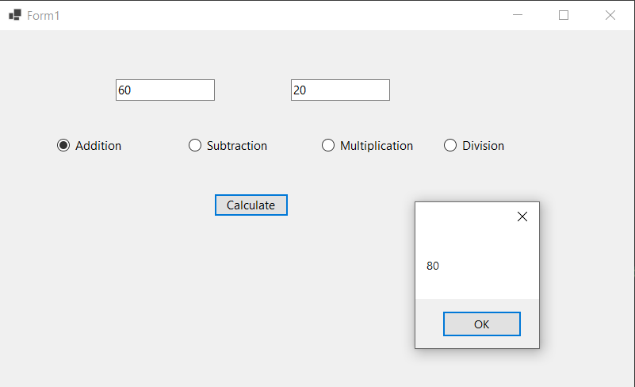

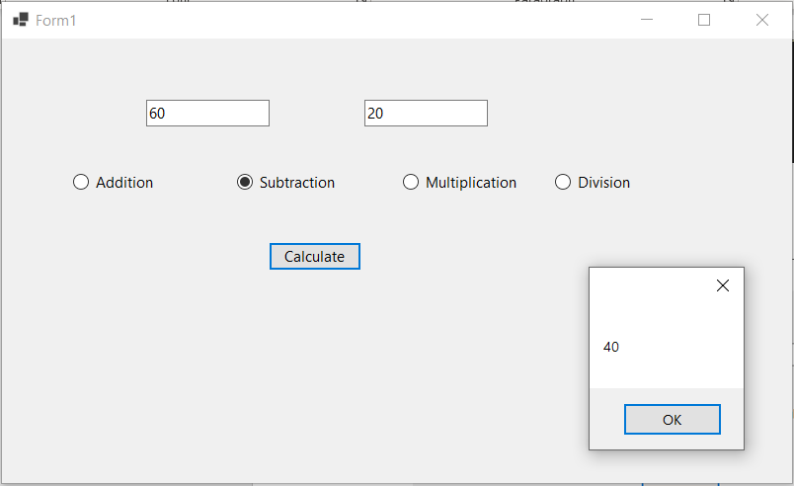

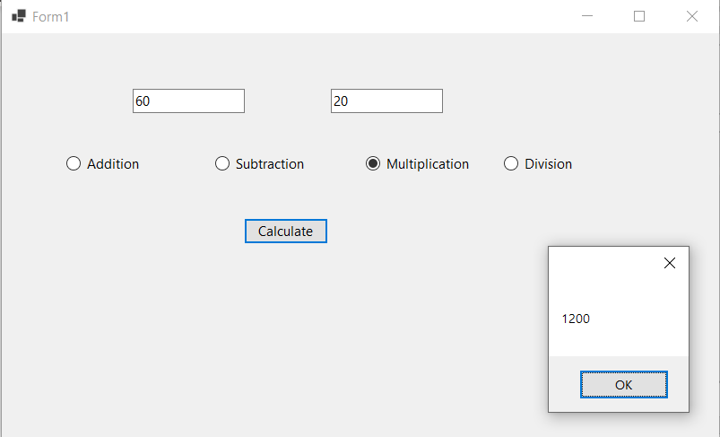

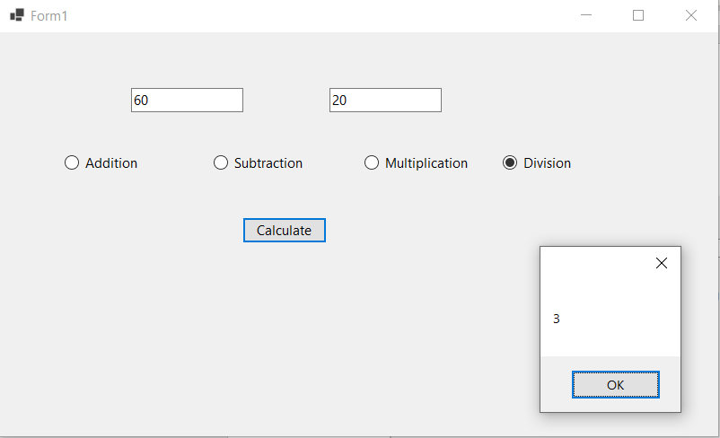

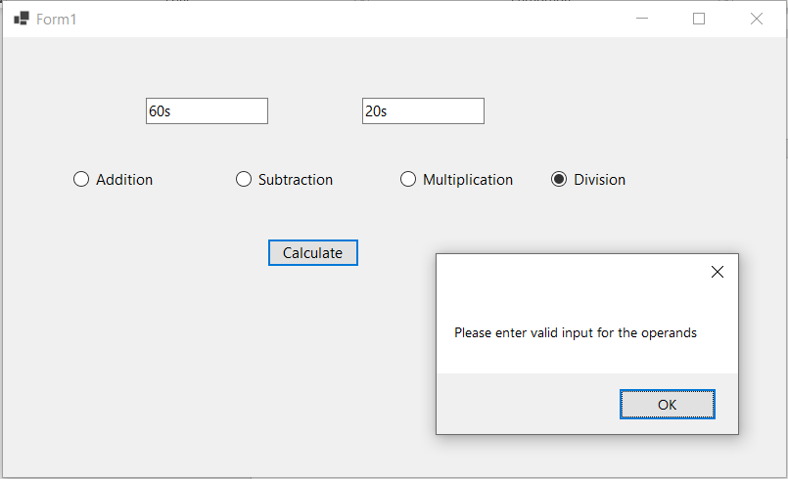

**Windows forms application 2**

**Form1.cs**

using System;

using System.Collections.Generic;

using System.ComponentModel;

using System.Data;

using System.Drawing;

using System.Linq;

using System.Text;

using System.Threading.Tasks;

using System.Windows.Forms;

namespace WindowsFormsApplication2

{

    public partial class Form1 : Form

    {

        public Form1()

        {

            InitializeComponent();

        }

        private void pictureBox1_Click(object sender, EventArgs e)

        {

        }

        private void button1_Click(object sender, EventArgs e)

        {

            OpenFileDialog openFileDialog1 = new OpenFileDialog

            {

                InitialDirectory = @"D:\",

                Filter = "image(*.jpg) | *.jpg"

            };

            if (openFileDialog1.ShowDialog() == DialogResult.OK)

            {

                pictureBox1.SizeMode = PictureBoxSizeMode.StretchImage;

                pictureBox1.Image = new Bitmap(openFileDialog1.FileName);

            }

        }

    }

}

**Form1.Designer.cs**

namespace WindowsFormsApplication2

{

    partial class Form1

    {

        /// <summary>

        ///  Required designer variable.

        /// </summary>

        private System.ComponentModel.IContainer components = null;

        /// <summary>

        ///  Clean up any resources being used.

        /// </summary>

        /// <param name="disposing">true if managed resources should be disposed; otherwise, false.</param>

        protected override void Dispose(bool disposing)

        {

            if (disposing && (components != null))

            {

                components.Dispose();

            }

            base.Dispose(disposing);

        }

        #region Windows Form Designer generated code

        /// <summary>

        ///  Required method for Designer support - do not modify

        ///  the contents of this method with the code editor.

        /// </summary>

        private void InitializeComponent()

        {

            this.openFileDialog1 = new System.Windows.Forms.OpenFileDialog();

            this.pictureBox1 = new System.Windows.Forms.PictureBox();

            this.button1 = new System.Windows.Forms.Button();

            ((System.ComponentModel.ISupportInitialize)(this.pictureBox1)).BeginInit();

            this.SuspendLayout();

            //

            // openFileDialog1

            //

            this.openFileDialog1.FileName = "openFileDialog1";

            //

            // pictureBox1

            //

            this.pictureBox1.Location = new System.Drawing.Point(59, 48);

            this.pictureBox1.Name = "pictureBox1";

            this.pictureBox1.Size = new System.Drawing.Size(700, 343);

            this.pictureBox1.TabIndex = 0;

            this.pictureBox1.TabStop = false;

            this.pictureBox1.Click += new System.EventHandler(this.pictureBox1_Click);

            //

            // button1

            //

            this.button1.Location = new System.Drawing.Point(320, 409);

            this.button1.Name = "button1";

            this.button1.Size = new System.Drawing.Size(94, 29);

            this.button1.TabIndex = 1;

            this.button1.Text = "button1";

            this.button1.UseVisualStyleBackColor = true;

            this.button1.Click += new System.EventHandler(this.button1_Click);

            //

            // Form1

            //

            this.AutoScaleDimensions = new System.Drawing.SizeF(8F, 20F);

            this.AutoScaleMode = System.Windows.Forms.AutoScaleMode.Font;

            this.ClientSize = new System.Drawing.Size(800, 450);

            this.Controls.Add(this.button1);

            this.Controls.Add(this.pictureBox1);

            this.Name = "Form1";

            this.Text = "Form1";

            ((System.ComponentModel.ISupportInitialize)(this.pictureBox1)).EndInit();

            this.ResumeLayout(false);

        }

        #endregion

        private System.Windows.Forms.OpenFileDialog openFileDialog1;

        private System.Windows.Forms.PictureBox pictureBox1;

        private System.Windows.Forms.Button button1;

    }

}

**Program.cs**

using System;

using System.Collections.Generic;

using System.Linq;

using System.Threading.Tasks;

using System.Windows.Forms;

namespace WindowsFormsApplication2

{

    static class Program

    {

        /// <summary>

        ///  The main entry point for the application.

        /// </summary>

        [STAThread]

        static void Main()

        {

            Application.SetHighDpiMode(HighDpiMode.SystemAware);

            Application.EnableVisualStyles();

            Application.SetCompatibleTextRenderingDefault(false);

            Application.Run(new Form1());

        }

    }

}

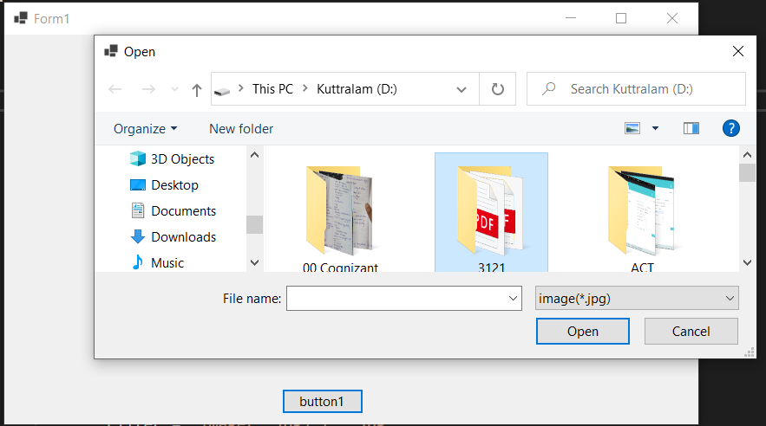**OUTPUT**

